**TASKS**

1) Implement Counter using Timer that take pulses from P3^4

#include <reg51.h>

unsigned int i = 0x00;

unsigned int j = 0x00;

void start_timer()

{

TMOD = 0x06;

IE = 0x82;

}

void timer() interrupt 0

{

TH0 = 0x00;

TL0 = 0x00;

}

void init()

{

TR0 = 1;

}

void main()

{

init();

start_timer();

while(1)

{

if(TL0>9)

{

TL0=0x00;

TH0=0x00;

}

P1=TL0;

}

}

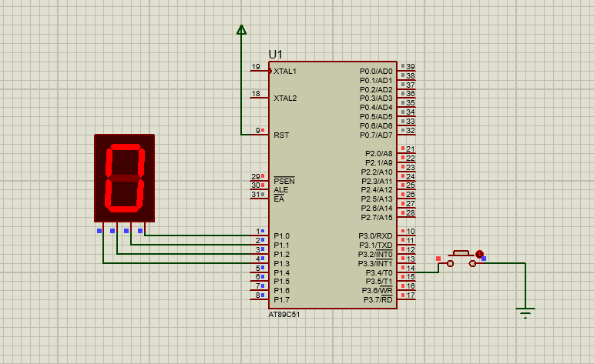

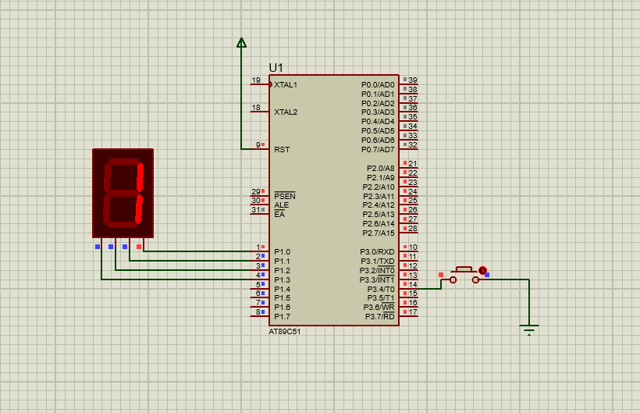

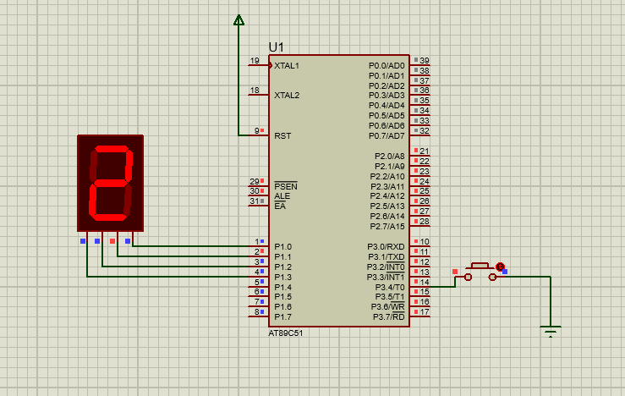

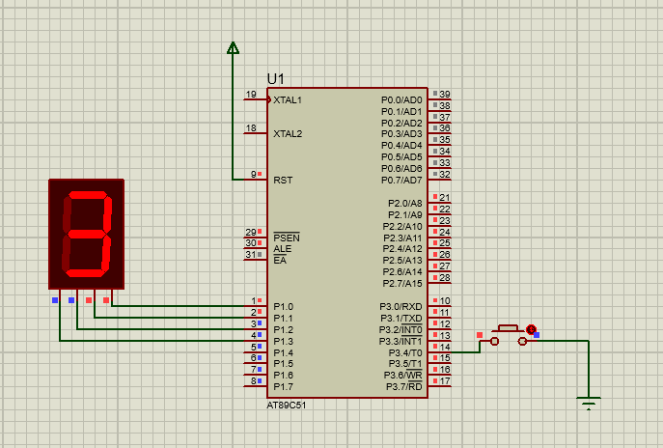

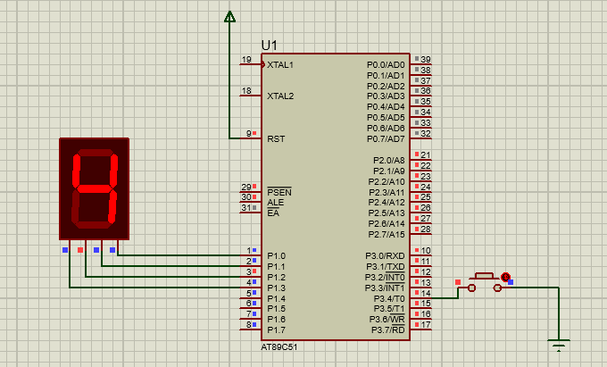

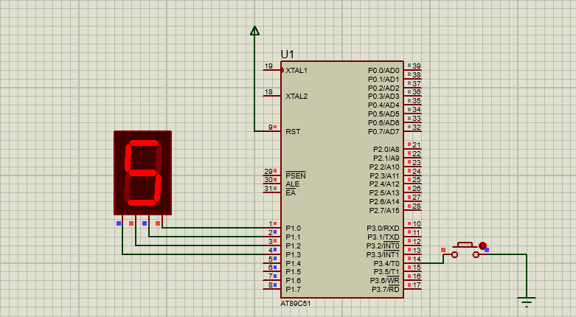

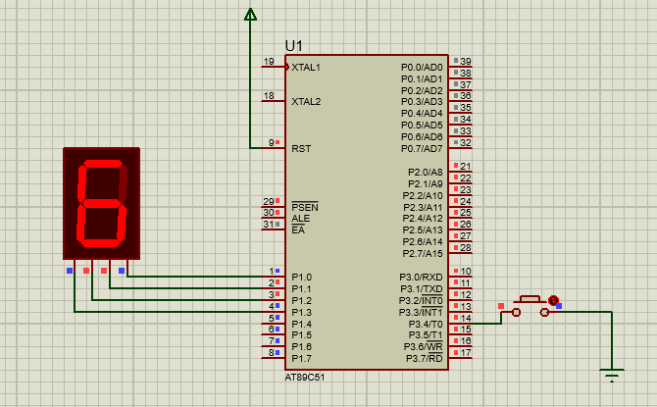

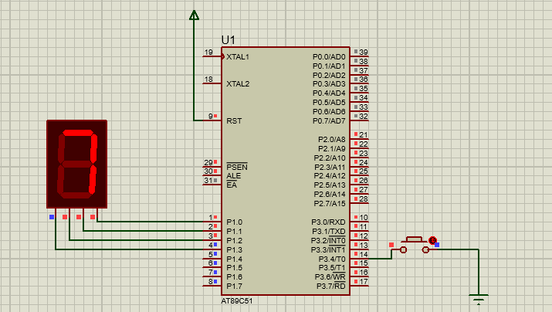

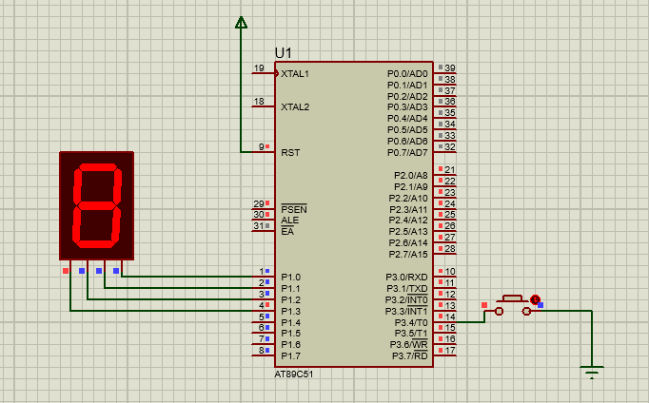

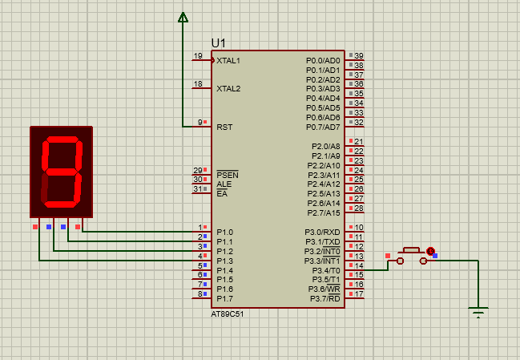

2) Implement Counter that counts from 0 to 9.

#include <reg51.h>

unsigned int i = 0x00;

unsigned int j = 0x00;

void Delay(){

int k=0;

for(k=0;k<10000;k++){}

}

void main()

{

while(1){

for(j=0x00; j<0x09; j=j+0x01) {

Delay();

P1 = j;

}

}

}

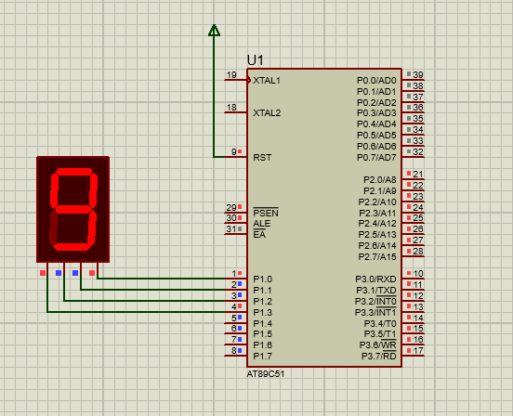

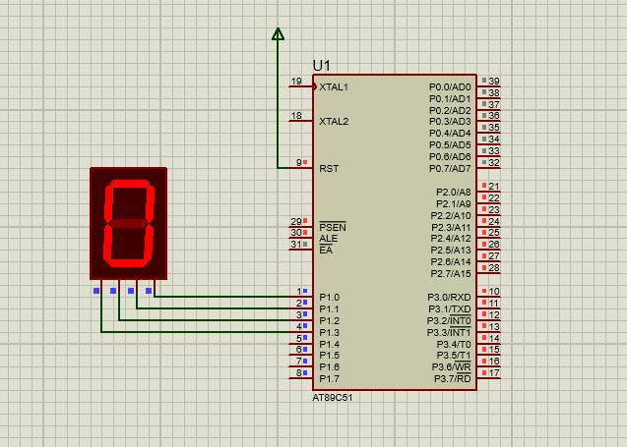

……....

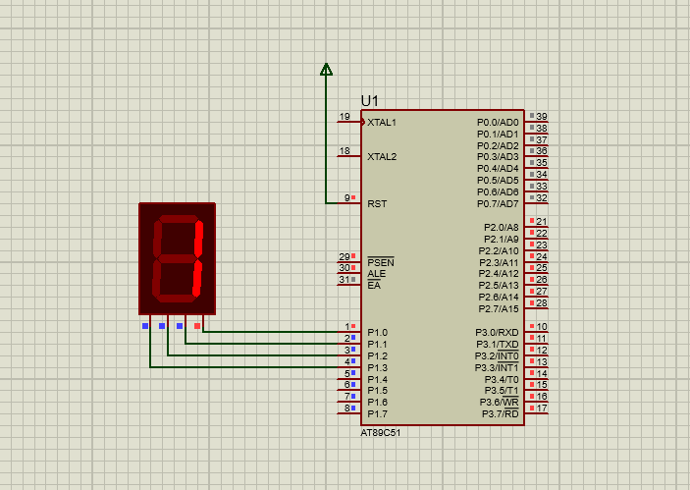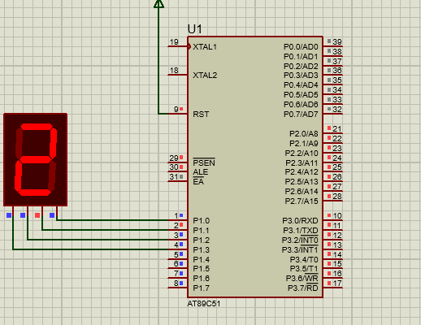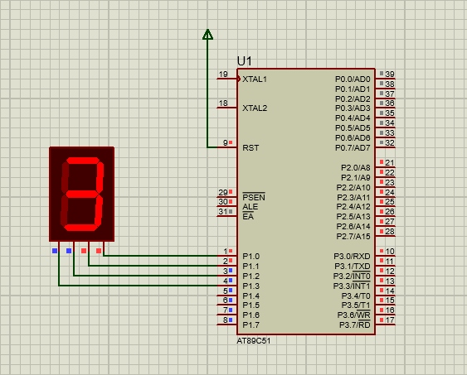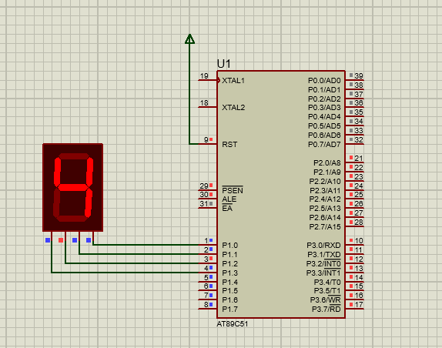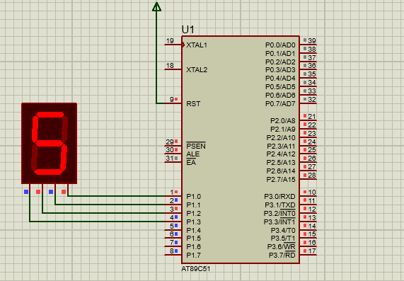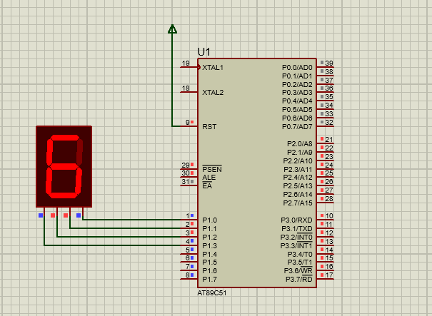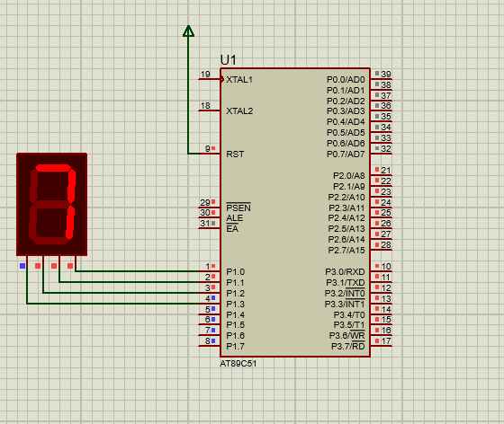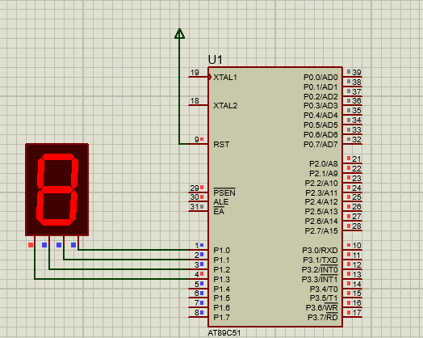

3) Implement Counter that counts from 00 to 99

#include <reg51.h>

unsigned int i = 0x00;

unsigned int j = 0x00;

void Delay(){

int k=0;

for(k=0;k<10000;k++){}

}

void main() {

while(1){

for(i=0; i<=0x90; i=i+0x10) {

for(j=0x00; j<0x09; j=j+0x01) {

Delay();

P1 = i|j;

}}}

}

